

**1.1 Project Description**

Electronic drum kits allow you to change the sound of your drum kit with a touch of a button. Studio-quality acoustic kits, huge arena rock kits, world and orchestral percussion, electronic and techno kits, funky hip-hop kits, and more are all immediately accessible. With hundreds of drum, percussion, and effects sounds at your fingertips, an electronic kit will let you play authentic sounds in wide variety of musical styles.

This makes electronic kits a great choice for small stages, churches, or anywhere stage volume may be a problem. At home, the sound can be monitored with headphones making late night and apartment drumming practical. And for recording enthusiasts, electronic drums make it easy to achieve professional sounding tracks by eliminating the need for multiple microphones and preamplifiers.



**1.2 Project profile**

|  |  |
| --- | --- |
| **Project name** | Elecro_music_drumpads |
| **Technology** | Android , JAVA |
| **Project Type** | Mobile Application |
| **Front End** | Android Studio 4.2.0 |
| **Email** | [Kewumoradiya278@gmail.com](mailto:Kewumoradiya278@gmail.com) |
| **Documentation Tools** | MS word 2007,Edraw max |
| **Developed By** | Moradiya Keval B. |
|  |  |



**2.1 Hardware and software Requirement**

# Developer side:-

|  |  |
| --- | --- |
| **Operating System** | Microsoft Windows 2007,2008,2010 |
| **RAM** | 4.00 GB Minimum |
|  | 8.00 GB Recommended |
| **Hard Disk(HDD)** | Minimum 512 GB |
| **Processor** | Intel i3 Dual Core 5th Generation |
| **Internet** | Required |

* **User side**

|  |  |
| --- | --- |
| **Operating System** | MicrosoftWindows 2007,2008,2010 |
| **Operating System** | **Android operating system with version 4.0 & higher** |
| **RAM** | 2 GB or higher |
| **Storage** | 22 Mb |
| **Internet** | Required |



**2.2 Technology used**

**Android:-**



# What is Android?

* + **Android** is a [mobile operating system](https://en.wikipedia.org/wiki/Mobile_operating_system) developed by [Google](https://en.wikipedia.org/wiki/Google). It is based on a modified version of the [Linux kernel](https://en.wikipedia.org/wiki/Linux_kernel) and other [open](https://en.wikipedia.org/wiki/Open-source_software) [source](https://en.wikipedia.org/wiki/Open-source_software) software, and is designed primarily for touch screen mobile devices such as [Smart phones](https://en.wikipedia.org/wiki/Smartphone) and [Tablets](https://en.wikipedia.org/wiki/Tablet_computer).
  + Android is a computing platform designed for use in some smart phones and other devices. This technology, which is owned by Google, Inc., includes an operating system, software, and applications.
  + In addition, Android was founded in [Palo Alto, California](https://en.wikipedia.org/wiki/Palo_Alto%2C_California), in October 2003 by [Andy Rubin](https://en.wikipedia.org/wiki/Andy_Rubin), [Rich Miner](https://en.wikipedia.org/wiki/Rich_Miner), Nick Sears, and Chris White. Applications ("[apps](https://en.wikipedia.org/wiki/Mobile_app)"), which extend the functionality of devices, are written using the [Android software development](https://en.wikipedia.org/wiki/Android_software_development) kit and, often, the [Java](https://en.wikipedia.org/wiki/Java_(programming_language)) programming language.
  + Java may be combined with [C](https://en.wikipedia.org/wiki/C_(programming_language))/[C++](https://en.wikipedia.org/wiki/C%2B%2B),together with a choice of non- default [runtimes](https://en.wikipedia.org/wiki/Runtime_library) that allow better C++ support.
  + The [Go](https://en.wikipedia.org/wiki/Go_(programming_language)) programming language is also supported, although with a limited set of [application programming interfaces](https://en.wikipedia.org/wiki/Application_programming_interface) (API). In May 2017, Google announced support for Android app development in the [Kotlin programming language](https://en.wikipedia.org/wiki/Kotlin_(programming_language)).

# Features & Specifications

* + These applications make life more comfortable and advanced for the users. Hardware that support Android are mainly based on [**ARM**](http://www.engineersgarage.com/articles/arm-advanced-risc-machines-processors)[**architecture**](http://www.engineersgarage.com/articles/arm-advanced-risc-machines-processors) **platform.**
  + Some of the current features and specifications of android are:
    1. Android applications are written in java programming
    2. language
    3. Android is available as open source for developers to develop applications which can be further used for selling in android market.
    4. There are around 200000 applications developed for android with over 3 billion+ downloads.

The market share for commonly used mobile OSs is shown in the following pie chart.

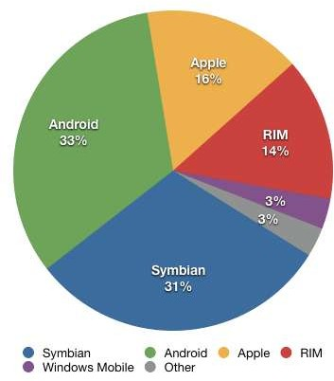

# Architecture Of Android

* + Android operating system is a stack of software components which is roughly divided into five sections and four main layers as shown below in the architecture diagram.
  + **Android architecture** or **Android software stack** is categorized into five parts:
    - 1. Linux kernel
      2. native libraries (middleware),
      3. Android Runtime
      4. Application Framework
      5. Applications
  + Let's see the android architecture first.

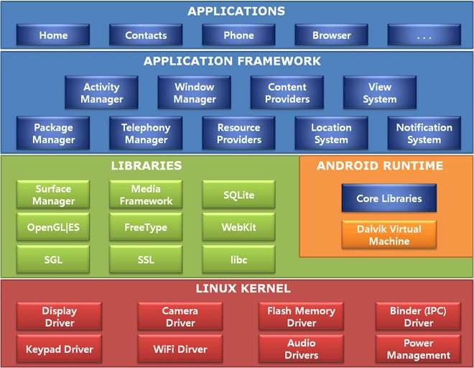

* **Android Version:-**

|  |  |  |  |  |
| --- | --- | --- | --- | --- |
| **Version** | **Code Name** | **Release date** | **API**  **level** | **First device** |
| **1.0** | Astro | Sepetember.23,2008 | 1 | - |
| **1.1** | Beta | February,9,2009 | 2 | - |
| **1.5** | Cupcake | April,30,2009 | 3 | - |
| **1.6** | Donut | September,26,2009 | 4 | - |
| **2.1** | Éclair | October,26,2009 | 5-7 | Nexus 1 |
| **2.2** | Froyo | May,20,2010 | 8 | HTC |
| **2.3** | Gingerbread | February,9,2011 | 10 | Nexus s |
| **3.0** | Honeycomb | February,22,2011 | 9 | Motorola XOOM |
| **4.0** | Ice Cream Sandwich | October 19,2011 | 15 | Galaxy nexus |
| **4.3** | Jelly Bean | July 24,2013 | 18 | Nexus 7 |
| **4.4** | Kit Kat | October 31,2013 | 19 | Nexus 5 |
| **5.1** | Lollipop | March 9,2015 | 22 | Android one |
| **6.0** | Marshmallow | October 5,2015 | 23 | Nexus 6p |
| **7.1** | Nougat | October 4,2016 | 25 | Pixel XL |
| **8.1** | Oreo | December 5,2017 | 27 | Nexus 5x |
| **9** | Pie | August 5,2018 | 28 | One plus 6 |

# Programming for Android :-

* + Android technology is based on Java software applications. This technology requires the use of a special software development kit (SDK) to create applications for an Android device.
  + The SDK is freely available for download from the Internet. For this reason, and because it will work on multiple operating systems, many software developers prefer Android technology over that used in other smart phones. Smart phones have evolved into devices that use touch screens for navigation.
  + Android technology provides specific application programming interface (API) modules to developers that take advantage of this.
  + The touch screen enables the user to select and scroll through information with the stroke of a finger.

# Functionality:-

## User

* + User Use to deferent type Elecro Music drums
  + If simple start use basic drums use
  + Also use party ware drums,and other different type drums play and save on your record history
  + Save record set and play on your favorite music
  + User can Start and stop activity follows
  + User can Share this application
  + User can give rate to our application



**3.1 Scope**

# Access application:-

* + user can access application without any registration and if they register the application they do not need to pay any charges

# User:-

* + User can play own your favorite music drums
  + User can record drums music
  + User can set song in music and also play any time record music
  + User can give rate to our application.



**3.2 Expected Advantage**

* + Save time
  + Easy to use

Application provide usable interface by which user can access the feature of this application any time easily.

* + Use for Entertainment purpose
  + High security
  + User friendly system



**4. Data dictionary**

# Activity(main java activity)

SpleshActivity Start Activity

# Xml File

|  |  |
| --- | --- |
| **activity_drum_demo.xml** | **drum_electric.xml** |
| **activity_game.xml** | drum_jazz.xml |
| **activity_intro.xml** | drum_loaders_progress.xml |
| **activity_main.xml** | exit_dialog.xml |
| **activity_second.xml** | file_row.xml |
| **activity_skip.xml** | item_ad.xml |
| **activity_song_picker.xml** | list_appstore_splash.xml |
| **activity_splesh.xml** | record_controls.xml |
| **activity_start.xml** | setup_overlay_controls.xml |
| **activity_thanks.xml** | song_list_row.xml |
| **ad_thanks.xml** | song_player_controls.xml |
| **custom_banner_large.xml** |  |
| **dialog_sample_files_list.xml** |  |
| **drum_africa.xml** |  |
| **drum_basic.xml** |  |
| **drum_concert.xml** |  |
| **drum_doublebass.xml** |  |

* **Java File**

|  |  |
| --- | --- |
| Dume Demo Activity.java | SecoundActivity.java |
| Game Activity.java | StageActivity.java |
| Main Activity.java | SpleshActivity.java |
| Start Activity.java |  |



**Input Design**

**Splesh screen**

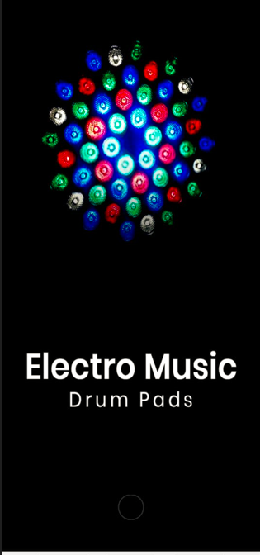

**Home page**

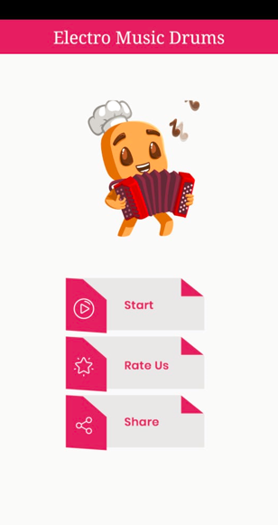

**Start page**

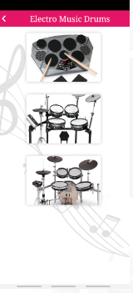

**Simple drum 1 music page**

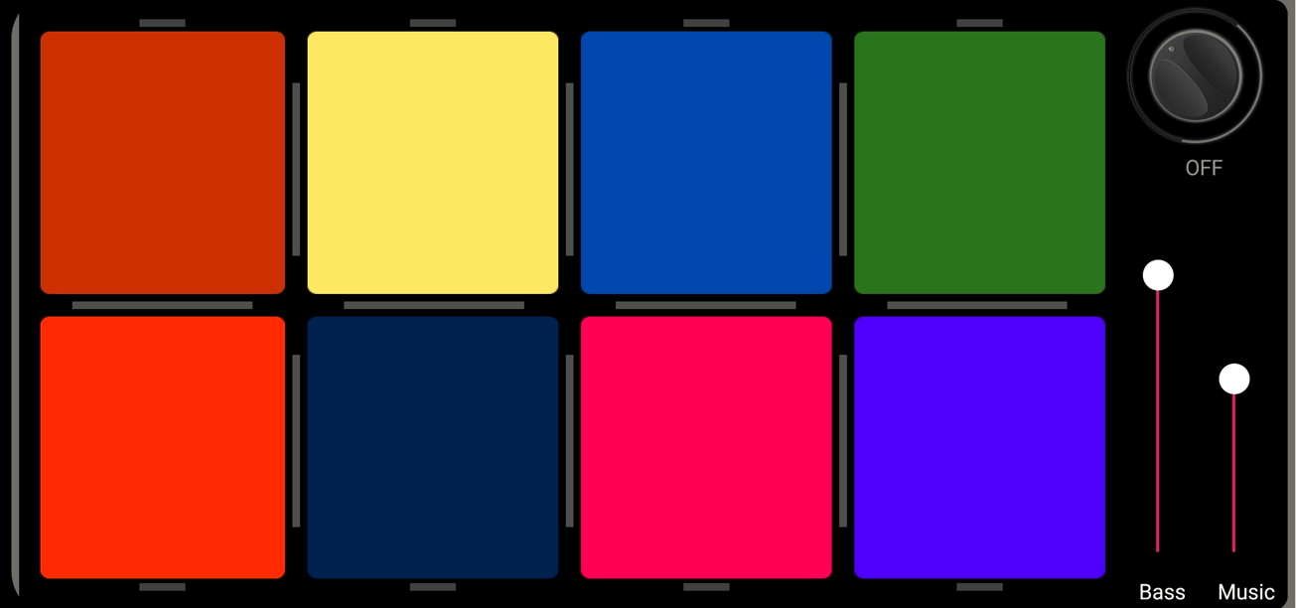

**Drum2 page**

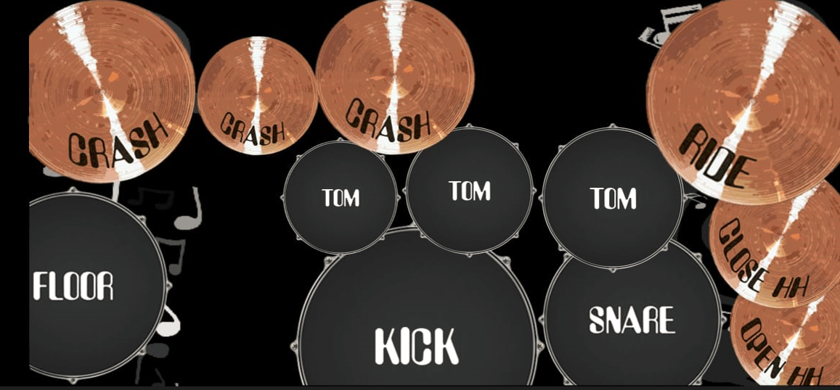

**Drum page 3**

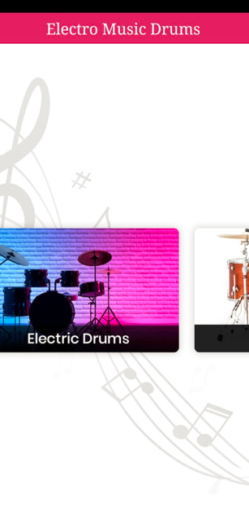



**References**

* + https://[www.javatpoint.com](http://www.javatpoint.com/)
  + [*https://www.android.com/intl/en_in/*](https://www.android.com/intl/en_in/)
  + [https://www.tutorialspoint.com](https://www.tutorialspoint.com/)
  + [https://www.journaldev.com](https://www.journaldev.com/)
  + [https://www.vogella.com](https://www.vogella.com/)
  + [https://javatpoint.com](https://javatpoint.com/)
  + <https://developer.android.com/studio/write/firebase>
  + https://[www.codementor.io](http://www.codementor.io/)